VIVU

Version 1.0

Table of Contents

**1. Main screen: 3**

**2. Scenario: Sign up 4**

**3. Verification screen: 5**

**4. Log-in screen: 6**

**5. Car list screen: 7**

**6. Booking screen: 8**

**7. Set date screen: 9**

**8. Payment screen: 10**

**9. Payment information screen (MasterCard): 10**

**10. Finished paying screen: 11**

**11. Driver’s information screen: 12**

**12. Driver’s driving license information screen: 13**

**13. Recent history screen: 14**

**14. Statistics screen: 15**

**15. Edit car screen: 17**

**16. Car management screen: 18**

**17. Edit Car List screen: 19**

## Main screen:

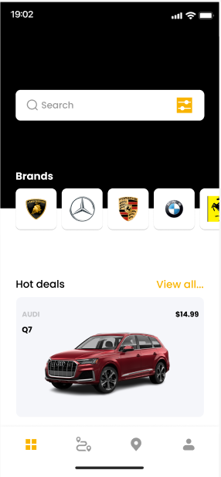

* **Purpose:** The primary UI of the application, displays when the application is started and the user has already logged into the account that can be accessed by all users.
* **What it shows:**
  + A search bar for searching for cars.
  + A carousel of different car branches for the user to choose from.
  + A list of current hot deals that can be extended by clicking on the “View all…” option.
  + Navigation buttons to navigate to other screens.
* **How to use:**
  + The user can search for certain cars by entering them into the search bar.
  + The user can also view cars from a certain branch by choosing one of the branches being shown.
  + The list of hot deals will be extended for viewing when the user clicks on the “View all…” option.
  + The user can go to other screens by choosing the icon that represents that screen at the bottom of the home screen.

## Scenario: Sign up

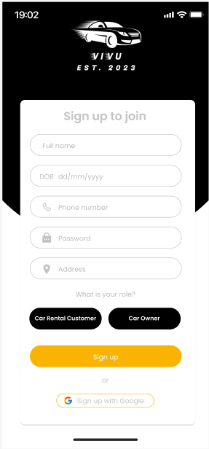

* **Purpose:** Creating a new account for the user that can be accessed by all users.
* **What it shows:**
  + A text box to enter the user’s full name.
  + A text box to enter the user’s date of birth.
  + A text box to enter the user’s phone number.
  + A text box for the user to set a password for the account.
  + A text box to enter the user’s address.
  + Two buttons representing two different roles for the user to choose: Car Rental Customer and Car Owner.
  + A signup button to submit the information.
  + An option to sign up with a Google account.
* **How to use:**
  + The user enters the required information including full name, date of birth, phone number, address, and sets a password for the account.
  + The user then chooses their role between being the customer or the car owner and clicks the sign up after finishing choosing.
  + The user can also choose to create a new account by using the Google account.

## Verification screen:

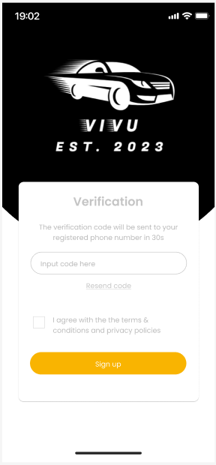

* **Purpose:** Verify before creating a new account.
* **What it shows:**
  + A text box for the user to enter the verification code that has just been sent to the registered phone number.
  + The resend code choice in case the code fails to be sent to the user.
  + A tick box confirming that the user has agreed to the terms & conditions before creating the account.
  + A signup button to finish creating a new account.
* **How to use:**
  + After finishing entering the required information, a verification code will be automatically sent to the phone number that the user just registered.
  + The user then enters the code after receiving it from the phone.
  + The user must tick in the tick box that represents that the user has agreed with the terms & conditions.
  + Finally, the user clicks the Signup button to finish the registration, and a new account is created.

## Log-in screen:

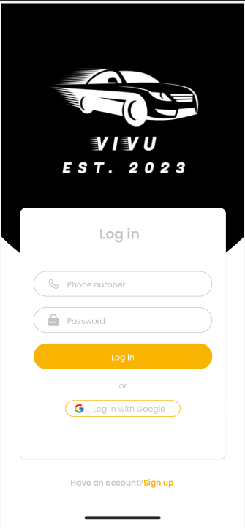

* **Purpose:** Entry page for the application that requires user identification and authentication.
* **What it shows:**
  + A text box for the user to enter the phone number and another one to enter the password.
  + The login button to authenticate the user.
  + An option to log in with a Google account.
  + An option to sign up if the user hasn’t got an account.
* **How to use:**
  + If the user already has an account, the user can enter the phone number and password to gain entry to the application.
  + The user then clicks the Log in button to access the account.
  + The user can also choose to log in with a Google account instead of entering a phone number and password.
  + If the user hasn’t got an account, the user can choose to sign up for an account.

## Car list screen:

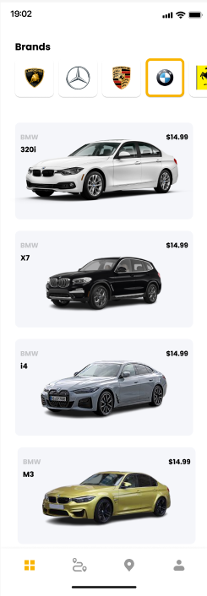

* **Purpose:** Displaying a list of cars from a certain branch for car rental customers.
* **What it shows:**
  + A list of car branches and show the branch that is currently chosen.
  + A list of cars of the same branch with the information of the model, the image of the car, and the price for renting.
* **How to use:**
  + The user chooses a branch to view the available cars with that branch.
  + After a list of cars has been shown, the user can click on a car to view further information and book that car if suitable.

## Booking screen:

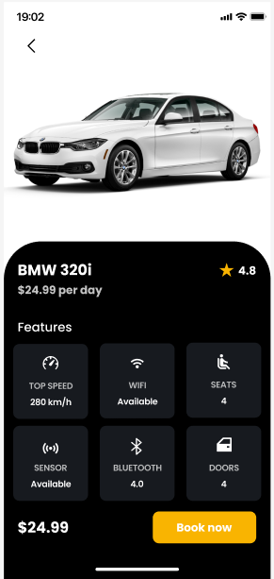

* **Purpose:** View the car’s information before choosing to book it for car rental customers only.
* **What it shows:**
  + An image of the chosen car.
  + The car’s branch and model with the renting price and its rating.
  + The car’s features include the highest speed, the availability of a Wi-Fi connection, the number of passenger seats, the availability of sensors and Bluetooth, and the number of doors.
  + A “Book now” button.
* **How to use:**
  + After viewing all the cars, the user clicks on a car to view further information about the car.
  + After viewing, the user can book that car by clicking on the “Book now” button on the lower right side of the screen.

## Set date screen:

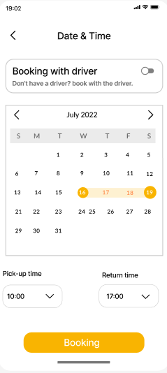

* **Purpose:** Choose a suitable time to rent the car for car rental customers only.
* **What it shows:**
  + A toggle for choosing whether the user wishes to book a driver together with the car.
  + A calendar represents the chosen renting period.
  + Two dropdowns represent the chosen time for picking up and returning the car.
  + A button to confirm the booking information.
* **How to use:**
  + If the user wants to book the car with a driver, the user can click on the toggle to choose “Booking with driver”.
  + The user then chooses the pick-up and return date on the calendar.
  + Then the user chooses the pick-up time from the “Pick-up time” dropbox and does the same for the return time.
  + After finishing choosing the date and time, the user submits the information by clicking the “Booking” button.

## Payment screen:

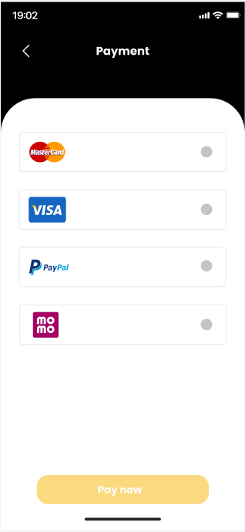

* **Purpose:** Choose a payment method to pay for the booking for car rental customers only.
* **What it shows:**
  + A list of payment methods available including MasterCard, Visa, PayPal, and Momo.
  + A “Pay now” button to perform the transaction that can only be clicked after the user finishes filling in the payment information.
* **How to use:**
  + The user chooses a payment method among the listed ones.
  + After choosing, the user will have to fill in some information about the payment method.

## Payment information screen (MasterCard):

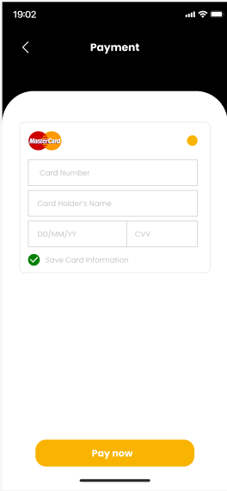

* **Purpose:** Ask for payment method information for car rental customers only.
* **What it shows:**
  + The name of the method of payment currently chosen.
  + Text boxes for the user to fill in required information about the payment method.
  + A radio button for the option “Save card information” the next time using it.
  + A “Pay now” button.
* **How to use:**
  + After choosing a method (Master Card), a list of text boxes will appear for the user to fill in the required information including the Card Number, Card Holder’s Name, issued date, card’s CVV.
  + The user can save this information the next time using this method by clicking the “Save Card Information” button.
  + Once the user has finished filling in all required information, the user can now click the “Pay now” button and the transaction will be performed automatically.

## Finished paying screen:

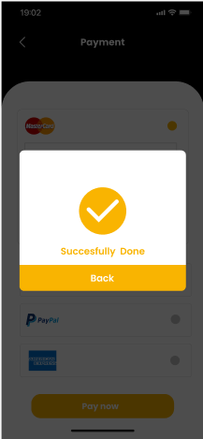

* **Purpose:** Notify that the transaction has been completed successfully.
* **What it shows:**
  + A pop-up window notifies the finished transaction.
  + A button to return.
* **How to use:**
  + Once the transaction has been completed successfully, a pop-up window will appear to notify the user.
  + The user clicks on the “Back” button to exit the screen.

## Driver’s information screen:

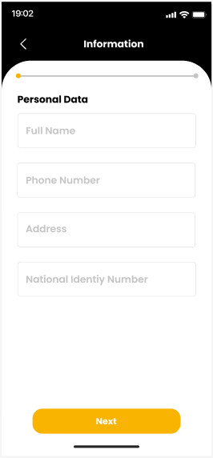

* **Purpose:** Get the driver’s information for car rental customers only.
* **What it shows:**
  + Four text boxes for the user to fill in the required information.
  + A button at the bottom of the screen to continue to the next screen.
* **How to use:**
  + The user fills in the required personal information including Full Name, Phone Number, Address, and National Identity Number.
  + After finishing filling out the information, the user clicks the “Next” button to go to the next screen.

## Driver’s driving license information screen:

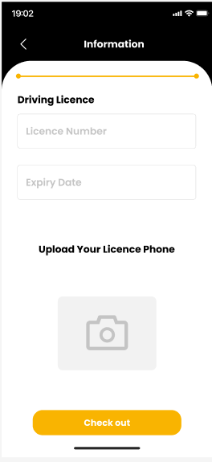

* **Purpose:** Get the driver’s driving license information for car rental customers only.
* **What it shows:**
  + Two text boxes for the user to fill in the required information.
  + An uploader for the user to upload the photo of the license.
  + A button at the bottom of the screen to check out.
* **How to use:**
  + The user fills in the required information about a driver's license including License Number and Expiry Date.
  + The user clicks on the uploader to upload the license image.
  + Finally the user clicks the “Check out” button to finish providing the required information for booking.

## Recent history screen:

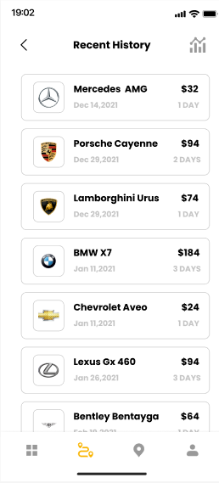

* **Purpose:** Displayed the past bookings.
* **What it shows:**
  + A button on the upper right to go to the statistics screen.
  + A list of recently finished bookings with each booking displaying the car’s branch and model, the booking date and period together with the total price of the booking.
  + Buttons at the bottom of the screen to navigate to other screens.
* **How to use:**
  + The user scrolls up and down to view the recent renting history.
  + The user clicks the statistics icon to go to the statistics screen.

## Statistics screen:

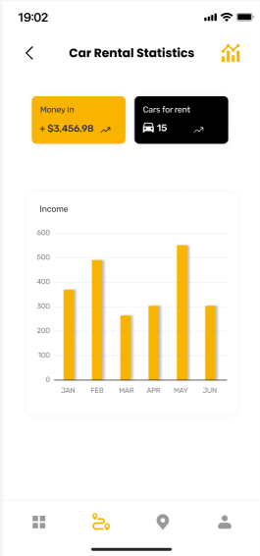

* **Purpose:** Displayed the car rental statistics to car owners.
* **What it shows:**
  + Two boxes show the total money for car rental and the total number of cars for rent.
  + A bar chart represents the total income in each month.
  + A return navigation at the upper left of the screen.
* **How to use:**
  + The user clicks the statistics icon to open the statistics screen.
  + The user can return to the previous screen by clicking the previous icon.

## Edit car screen:

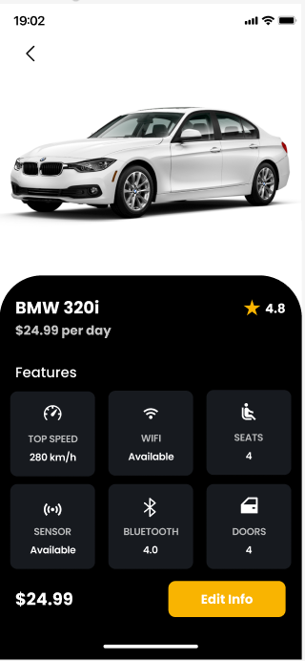

* **Purpose:** For the car's owner to check the car's information.
* **What it shows:**
  + An image of the chosen car to edit.
  + The car’s branch and model with the renting price and its rating.
  + The car’s features include the highest speed, the availability of a Wi-Fi connection, the number of passenger seats, the availability of sensors and Bluetooth, and the number of doors.
  + A “Edit info” button.
* **How to use:**
  + The user chooses the car that needs to be edited and the screen will show up.
  + After viewing, the user can click on the “Edit Info” button if there is information that needs to be updated.

## Car management screen:

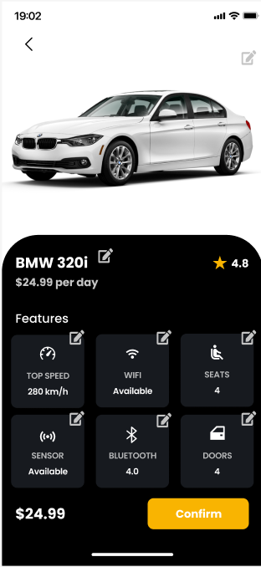

* **Purpose:** For the car’s owner to change the car’s information.
* **What it shows:**
  + An image of the chosen car to edit with the edit icon.
  + The car’s branch and model with the renting price and the edit icon.
  + The car’s features that can be edited including the highest speed, the availability of Wifi connection, the number of passenger seats, the availability of sensor and Bluetooth, and the number of doors and the edit icon.
  + A “Confirm” button.
* **How to use:**
  + The user clicks on the edit icon on the top left of the information that needs to be edited.
  + After finishing editing, the user clicks the “Confirm” button to save all the information.

## Edit Car List screen:

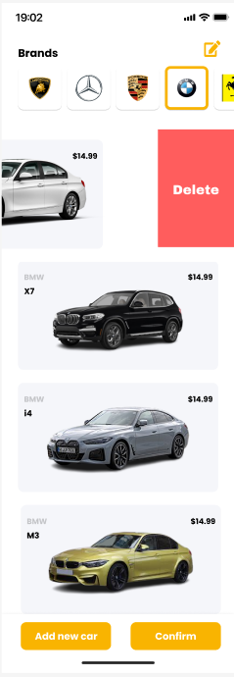

* **Purpose:** For the car’s owner to edit the car list.
* **What it shows:**
  + A list of cars for each brand and an edit icon.
  + Delete button for each car.
  + An “Add new car” and a “Confirm” button.
* **How to use:**
  + The user clicks on the edit icon on the top left to edit the car list.
  + The user swipes the car image to the left and the “Delete” button will appear, clicking on the button will delete the car.
  + The user clicks on the “Add new car” to go to the Add new car screen.
  + After finishing editing, the user clicks the “Confirm” button to save all the information.